BÁO CÁO THỰC HÀNH LAB 1  
LẬP TRÌNH HƯỚNG ĐỐI TƯỢNG

# The Very First Java Programs

## *2.2.1* Write, compile the first Java application:

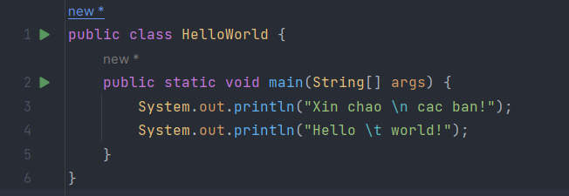

*Kết quả*

## 2.2.2 Write, compile the first dialog Java program

### 

## 2.2.3 Write, compile the first input dialog Java application

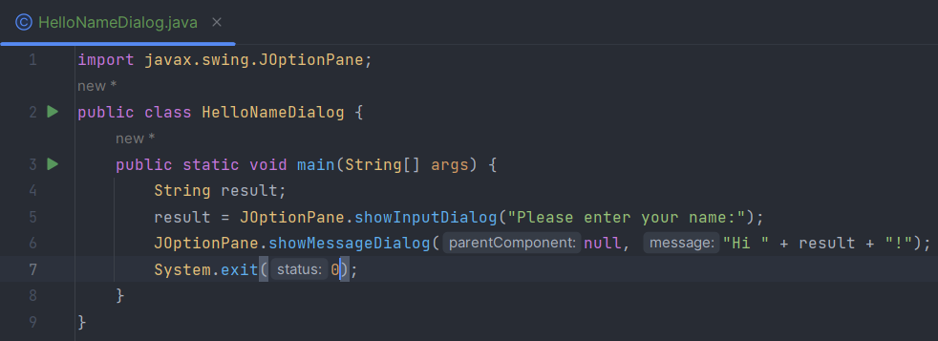

## 2.2.4 Write, compile, and run the following example:

## 2.2.5 Write a program to calculate sum, difference, product, and quotient of 2 double numbers which are entered by users.

**Notes**

* To convert from String to double, you can use

**double num1 = Double.parseDouble(strNum1)**

* Check the divisor of the division

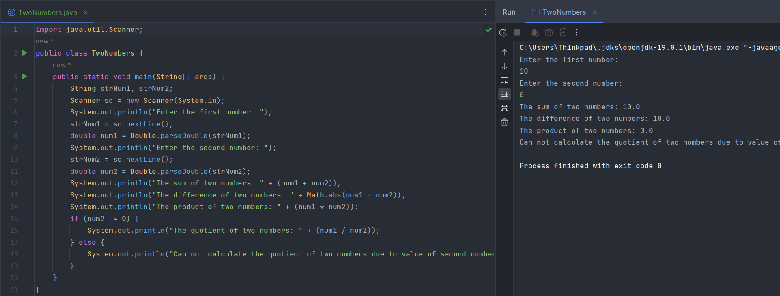

## 2.2.6 Write a program to solve: the first-degree equation with one variable and system of first-degree equations with two variable.

## 2.2.7 Write a program to calculate sum, difference, product, and quotient of 2 double numbers which are entered by users.

## 2.2.8 Write a program to calculate sum, difference, product, and quotient of 2 double numbers which are entered by users.